

CHAROTAR UNIVERSITY OF SCIENCE AND TECHNOLOGY

FACULTY OF TECHNOLOGY AND ENGINEERING

B. TECH (IT/CE/CSE/AIML)

Practical : 9
Practical Statement:
• Optimize the React frontend of the Task Management application by
implementing lazy loading for route-based components.
• Apply React.lazy() and Suspense to at least the Projects and Contact
routes (or equivalent route-based components).
• Provide a meaningful fallback UI while a lazy-loaded chunk is loading.
• Measure and compare bundle size and load time before and after
optimization using browser developer tools.
• Document the before/after comparison with screenshots or recorded
values.
Screenshots (Supplementary Problems are also implemented):

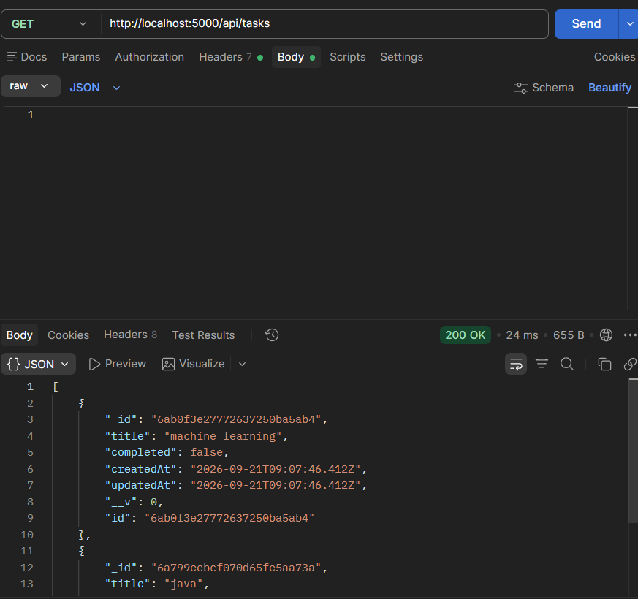
Sent request to tasks route

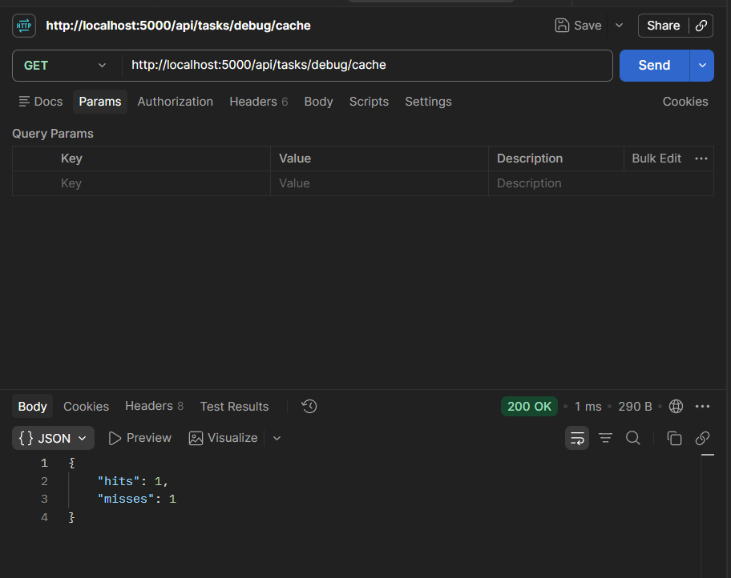
Cache working…

Github Repo Link: https://github.com/Gauravk6531/Advanced-Web-Development-Frameworks/tree/Practical_6

Key Questions:

1. Why must the cache be invalidated on every write operation?
Answer: A cached response represents database state at the time it was read. After a successful create, update, or delete, that response may no longer be correct. Without invalidation, GET /api/tasks could omit a new task or show an old/deleted task, and GET /api/tasks/:id could return outdated details until the TTL expires. Invalidating the relevant keys immediately keeps subsequent reads consistent with the successful write; the TTL is a fallback for entries that are not explicitly invalidated.

2. What is a reasonable TTL for task data, and what trade-off does TTL length represent?
Answer: A 60-second TTL is a reasonable starting point for a task-management lab: it allows repeated reads to reuse results while bounding the maximum lifetime of an entry that is not invalidated. A longer TTL can improve cache-hit rate and reduce database reads, but increases the maximum period of staleness if invalidation is missed. A shorter TTL improves freshness but causes more cache misses and database queries. Successful write invalidation is still required regardless of TTL.

3. Why is node-cache unsuitable for a multi-server or multi-instance deployment?
Answer: node-cache stores entries in the memory of one Node.js process. Each server instance therefore has separate values and separate hit/miss counters. A write handled by one instance cannot invalidate another instance?s cache, so different users may receive different or stale data; restarting an instance also clears its cache. A shared cache such as Redis, with coordinated invalidation, is more appropriate when multiple instances must serve consistent data.

